**CURESPOT: A TELEMEDICINE KIOSK**

India is becoming a hub for medical tourism but all these facilities are not available to local residents who happen to be poor.

Up to 50% of all villagers have no access to healthcare providers.

Number of hospitals and dispensaries are insufficient in comparison to our vast population.

Health services especially allopathic are quite expensive.

**PROBLEMS IN HEALTHCARE**

* Healthcare is the right of every individual but lack of quality infrastructure, dearth of qualified medical functionaries, and non- access to basic medicines and medical facilities thwarts its reach to 60% of population in India.
* A majority of 700 million people lives in rural areas where the condition of medical facilities is deplorable. Considering the picture of grim facts there is a dire need of new practices and procedures to ensure that quality and timely healthcare reaches the deprived corners of the Indian villages.
* Though a lot of policies and programs are being run by the Government but the success and effectiveness of these programs is questionable due to gaps in the implementation. In rural India, where the number of Primary health care centres (PHCs) is limited, 8% of the centres do not have doctors or medical staff, 39% do not have lab technicians and 18% PHCs do not even have a pharmacist.
* India also accounts for the largest number of maternity deaths. A majority of these are in rural areas where maternal health care is poor. Even in private sector, health care is often confined to family planning and antenatal care and do not extend to more critical services like labour and  delivery, where proper medical care can save life in the case of complications.
* Due to non-accessibility to public health care and low quality of health care services, a majority of people in India turn to the local private health sector as their first choice of care. If we look at the health landscape of India 92 percent of health care visits are to private providers of which 70 percent is urban population. Government reluctance toward the health care appears in that the roughly 0.9% of the total gross domestic product is allocated for health care. Spending average 14% of the household income on health care by the poor house hold varying from 1.3% in Tamil Nadu to about 37% in Jalore (Rajasthan) suggests people's reluctance toward health care putting it in a side corner then other priority. Only 0.5% of the rural enjoy basic sanitation facilities with a major population affected by the various health ailments owing to lack of sanitation coupled with polluted waters.
* It is a common complaint of people that government health functionaries are struck with non-availability of medical staff. In one of the study, it was indicated that 143 public facilities found absenteeism of 45% doctors from PHCs with 56% of time found to be closed with an unpredictable pattern of closure and absenteeism during regular hour visit.[[2](https://www.ncbi.nlm.nih.gov/pmc/articles/PMC4014652/#ref2)] A survey report from Madhya Pradesh in 2007 states that out of 24,807 qualified doctors and 94,026 qualified paramedical staff mapped in the survey in the state, 18,757 (75.6%) and 67,793 (72.1%) were working in the private sector respectively highlighting the government failure to provide basic infrastructure to doctors and other health care workers in rural areas.

**FACTS AND FIGURES SHOWING THE CURRENT CONDITION**

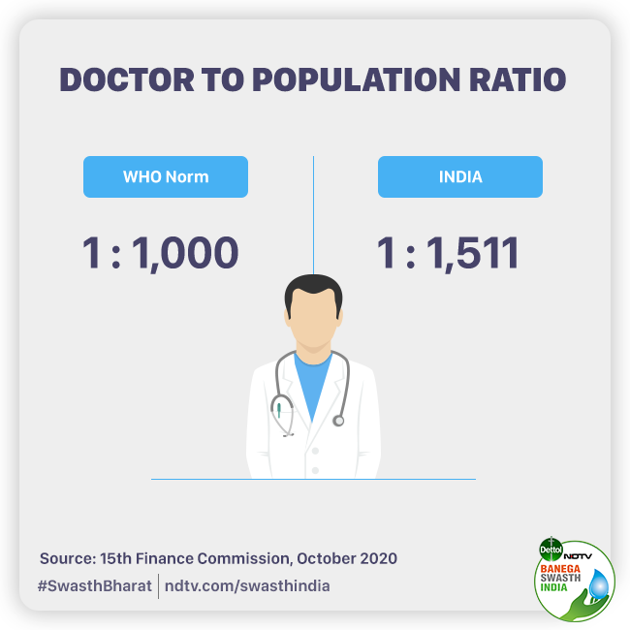

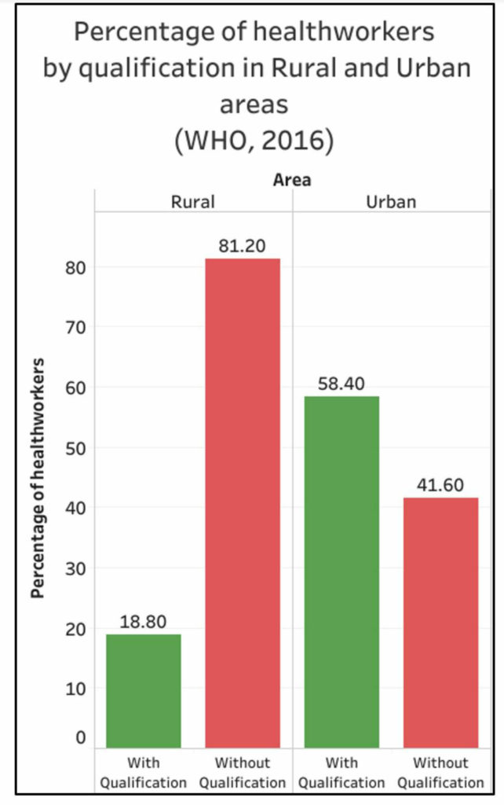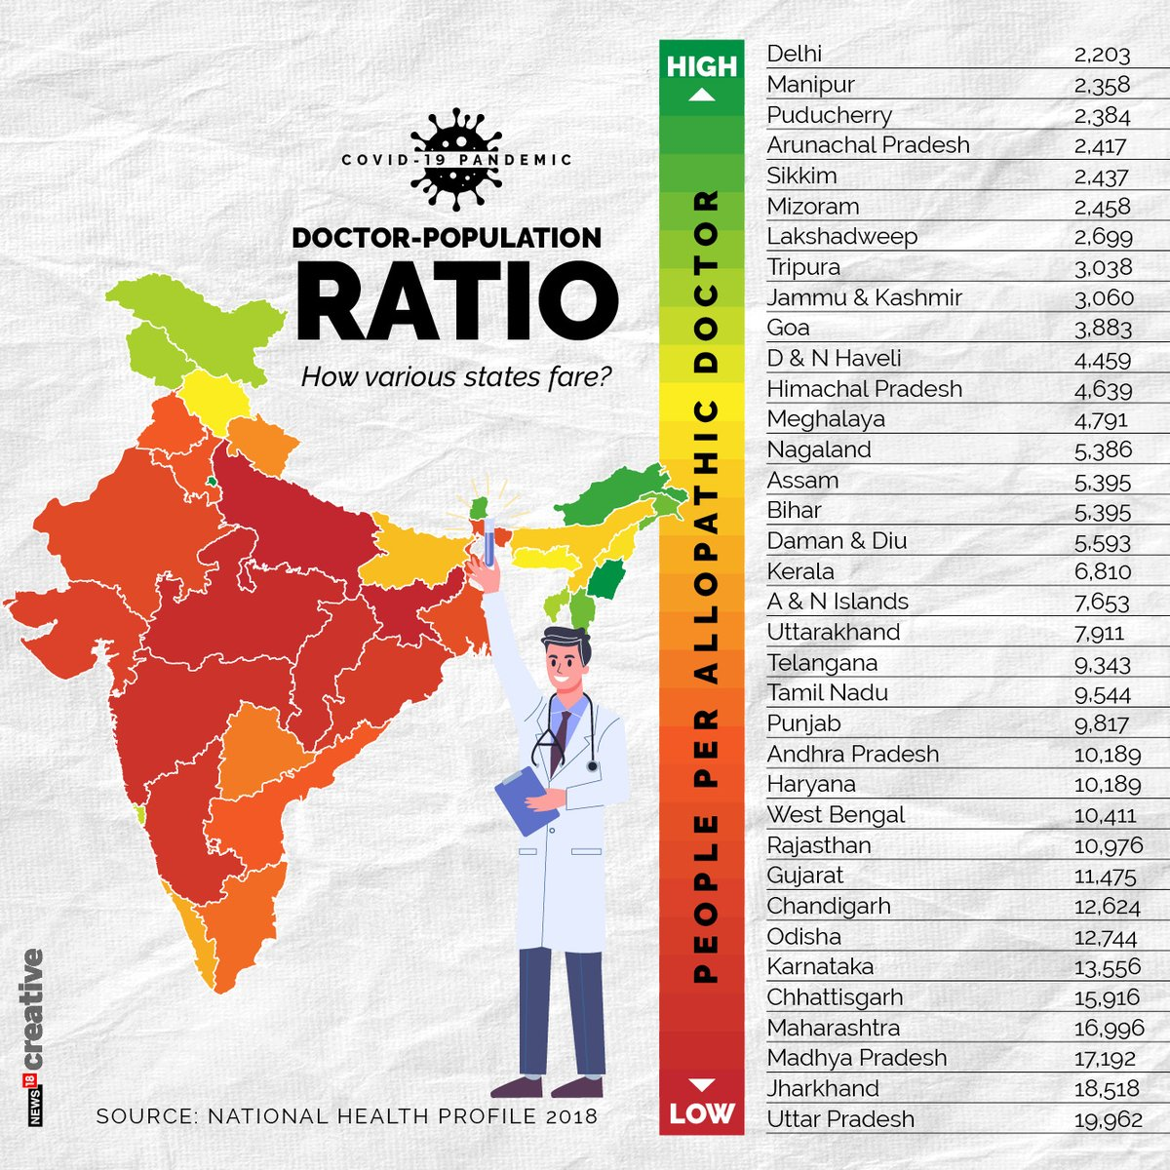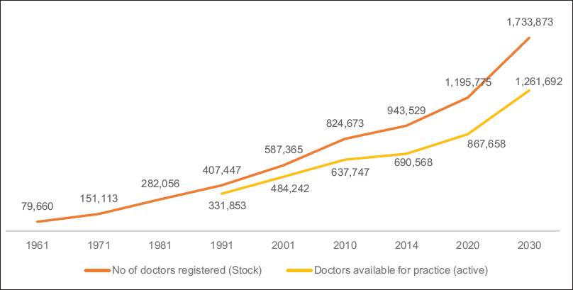

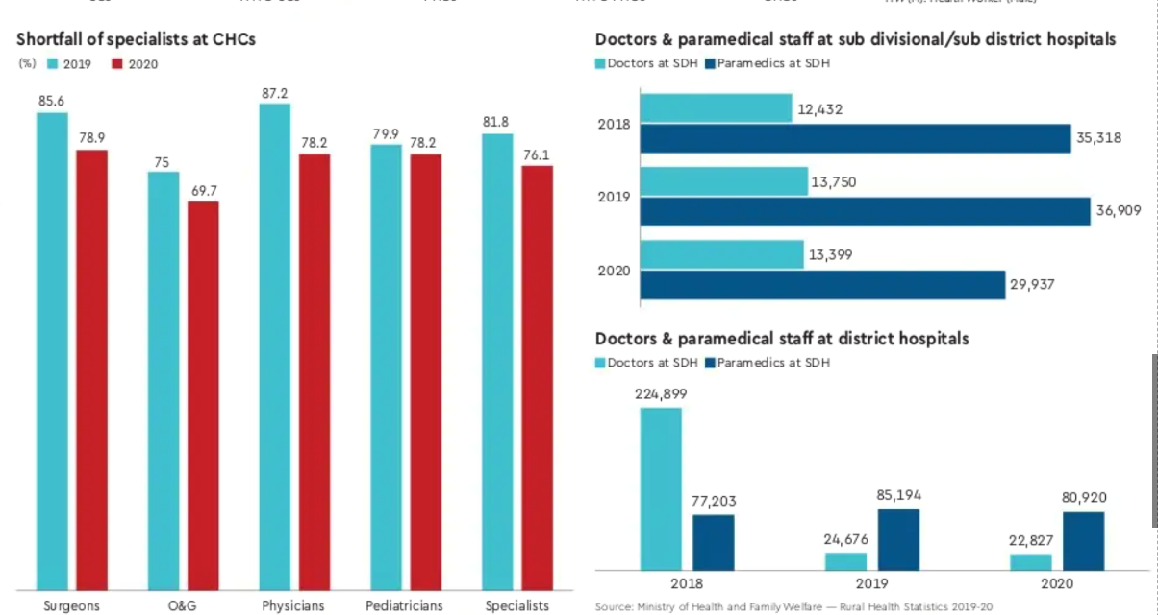

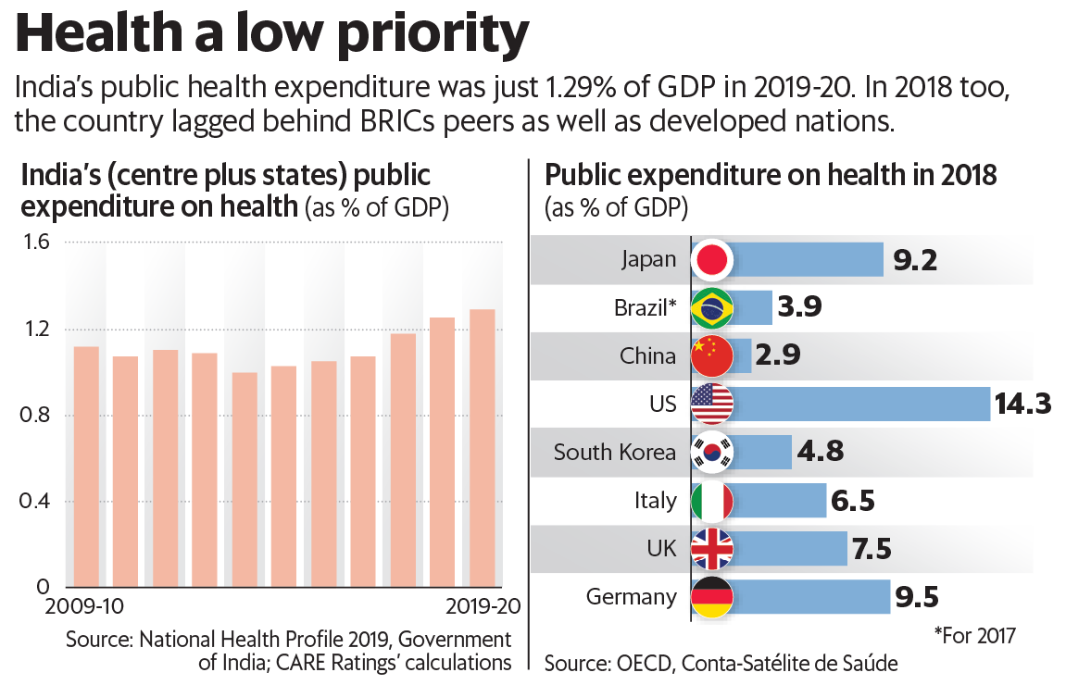

**WHAT IS TELEHEALTH? **

Telemedicine, also referred to as telehealth or e-medicine, is the remote delivery of healthcare services, including exams and consultations, over the telecommunications infrastructure. Telemedicine allows healthcare providers to evaluate, diagnose and treat patients [without the need for an in-person visit](https://www.techtarget.com/searchhealthit/feature/Telehealth-technologies-help-save-healthcare-organization-46-million-and-more). Patients can communicate with physicians from their homes by using their own personal technology or by visiting a dedicated telehealth kiosk.

Telemedicine can be classified into three main categories:

* **Interactive telemedicine/telehealth** - allows physicians and patients to communicate in real time. Such sessions can be conducted in the patient's home or at a designated medical kiosk. Interactions include telephone conversations or [the use of video conferencing software](https://www.techtarget.com/searchunifiedcommunications/tip/Video-key-to-coronavirus-business-continuity-planning) that complies with HIPAA regulations.
* **Remote patient monitoring** - also known as telemonitoring, [allows patients to be monitored in their homes](https://www.techtarget.com/searchhealthit/tip/Do-benefits-of-remote-patient-monitoring-outweigh-challenges) using mobile devices that collect data about temperature, blood sugar levels, blood pressure or other vital signs.
* **Store-and-forward** - also known as asynchronous telemedicine, lets one healthcare provider share patient information, such as lab results, with another healthcare provider.

**Advantages of telemedicine**

Some of the benefits of telemedicine for patients include:

* **Convenience**: Patients do not have to take time away from work for an appointment. There is also no travel time or associated expenses, such as paying for gas or child care.
* **Increased access**: Patients in rural areas can obtain specialty services, such a mental health treatment or post-surgery follow up, that they otherwise might not get without traveling a large distance for an in-person visit. Similarly, patients who live in federally designated, underserved areas have increased access to primary, dental and mental healthcare.

Telemedicine can lower healthcare costs, drive up efficiency and revenue, provide your patients better access to healthcare services, and ultimately get happier, healthier patients who stay in your organization.

One of the primary benefits of telehealth in rural areas is that it can help rural Indians overcome significant barriers to care, such as:

* Geographic distance from specialists and treatment centres
* Minimal public transportation
* Health care provider shortages

**OUR INNOVATION**

**INTRODUCTION TO CURESPOT**

* Curespot is a telemedicine kiosk designed to provide
* Adequate and quality healthcare in rural areas. It is an easy-to-use solution especially designed to provide easy and affordable treatment. Our vision is to fill the void in healthcare infrastructure.

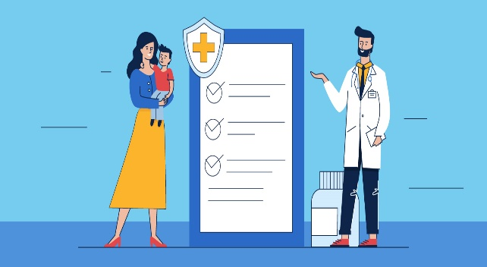

**CURESPOT IS…**

**TIME AND MONEY SAVING**: It saves time as patients don’t have to travel cities to get quality treatment.

Thus, it saves the travelling cost of the patient and their relative.

**RURAL ORIENTED**: It is rural oriented as the user interface is designed in such a way that it interacts with patient in Hindi, so that the illiterate class of people can also get advantage of kiosk.

**PROVIDING QUALITY HEALTHCARE**: Curespot connects the patient to the well qualified doctors and holds the historical data of patient for future reference.

**STRATEGY AND EXECUTION OF CURESPOT**

**01**

**Health Check-up :** Multiple sensors and cameras are used to take vitals and calculate health parameters like body fat ,bmi , bmr etc.

**02**

**Speech Recognition:** User is asked questions, entire conversation with doctor is also recorded and translated in Hindi text, symptoms are then extracted from the text for further use in machine learning.

**03**

**Machine Learning**: All the vitals, health parameters and symptoms are taken in account and a machine learning model is applied on them to predict the possible prognosis.

**WHAT MAKES US DIFFERENT?**

**Curespot is easy to use because of its user-friendly interface created in Hindi.**

The user interface is made so interactive that the illiterate class of people can access it easily. The Hindi language based interface makes the system user-friendly and easy to use.

**Printed prescription comprising of reports.**

The printed prescription is provided by Curespot that consists of the reports of initial tests taken by the assistant, it helps the user to track his health also Curespot holds the historical data of the patient.

**Diagnosis, medicines and suggestions by doctor.**

Patients will get in hand reports and prescription. Doctors can prescribe medicines and can suggest precautions according to the disease.

**FEATURES OF CURESPOT**

**Face Recognition**

**Video Consultation**

**Disease prediction**

**Electronic health records**

**Printed prescription**

**Instant diagnostic reports**

**Health monitoring sensors**

**In hand medical dispenser**

**APPLICATIONS OF CURESPOT**

**Rural Areas and Remote locations**: Curespot is of great advantage for people living in remote areas. This will connect people to specialist doctors who lives far away.

**Disaster prone areas:** Curespot, when installed near disaster prone areas would serve large number of people and also reduce the chances or the posibilities of transmission of contagious diseases.

**Public places:** Curespot can be used to serve a large number of people in public places such as schools, colleges, railway stations, airports etc.

**OUR VISION**

Curespot is a telemedicine kiosk equipped with sensors and artificial intelligence designed to provide and improve doctor-patient consultation. We’ve tried to make it more accessible by designing the solution in native languages such as Hindi so that even illiterate class of people can use it. We’re using Natural language processing to extract symptoms from input given by patients. We’re using machine learning model to predict prognosis based on the vitals given through sensors and symptoms extracted from consultation with the doctors. The extracted symptoms and predicted disease can help doctors narrow down the scope of diagnosis. With our solution Doctors can provide prescription and supervise drug oversight. Our solution makes it possible for you to leverage the expertise of specialists who are not nearby.

When it comes to serious health issues, YOU WANT TO CONSULT WITH THE BEST NOT THE NEAREST

**By using curespot user can:**

* **Save time and money.**
* **Consult specialist doctors by the ease of their own village.**
* **Hindi interface made it easy to understand and access by user.**
* **Get printed prescription.**
* **Get in hand reports of vitals taken.**
* **Various vitals taken by kiosk and sent to doctors, so that doctor can determine disease.**

**Applications**

Main application of this telemedicine kiosk is to establish healthcare facilities for rural India.

Other application may include, deployment in colleges, schools, railway stations, airports etc.

Companies can greatly benefit from our solution.

Our solution can also be used in camps, during disasters to avoid transmission of contagious diseases and to provide adequate healthcare.

**Curespot has:-**

* Hindi Speech Recognition and Chatbot
* 130+ Symptoms
* Advanced vitals like blood pressure, blood sugar etc
* Machine Learning and AI
* Disease Prediction and Historical medical reports